Region has been chosen: Asia pacific- Mumbai

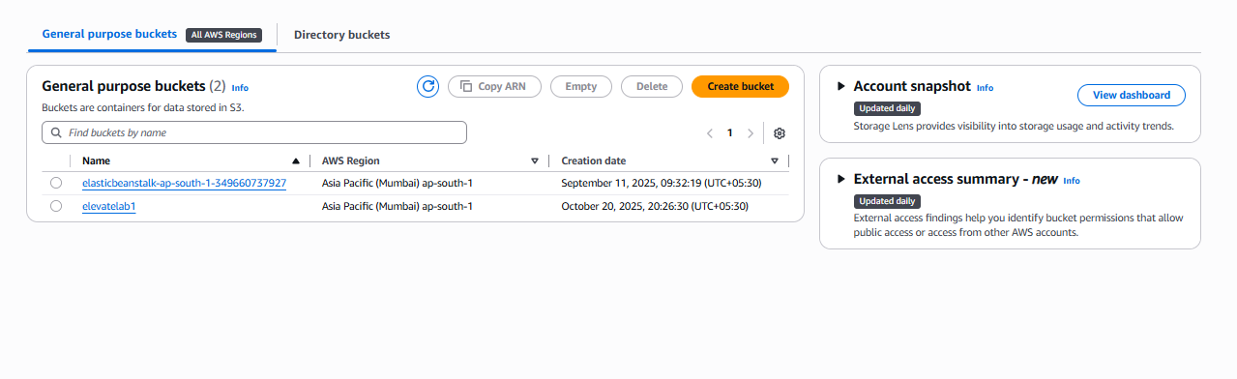

Creating a private bucket: elevatelab1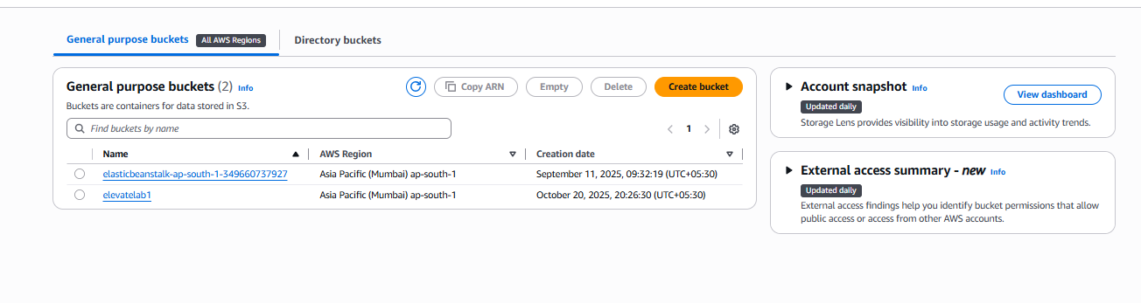Uploading a text file:

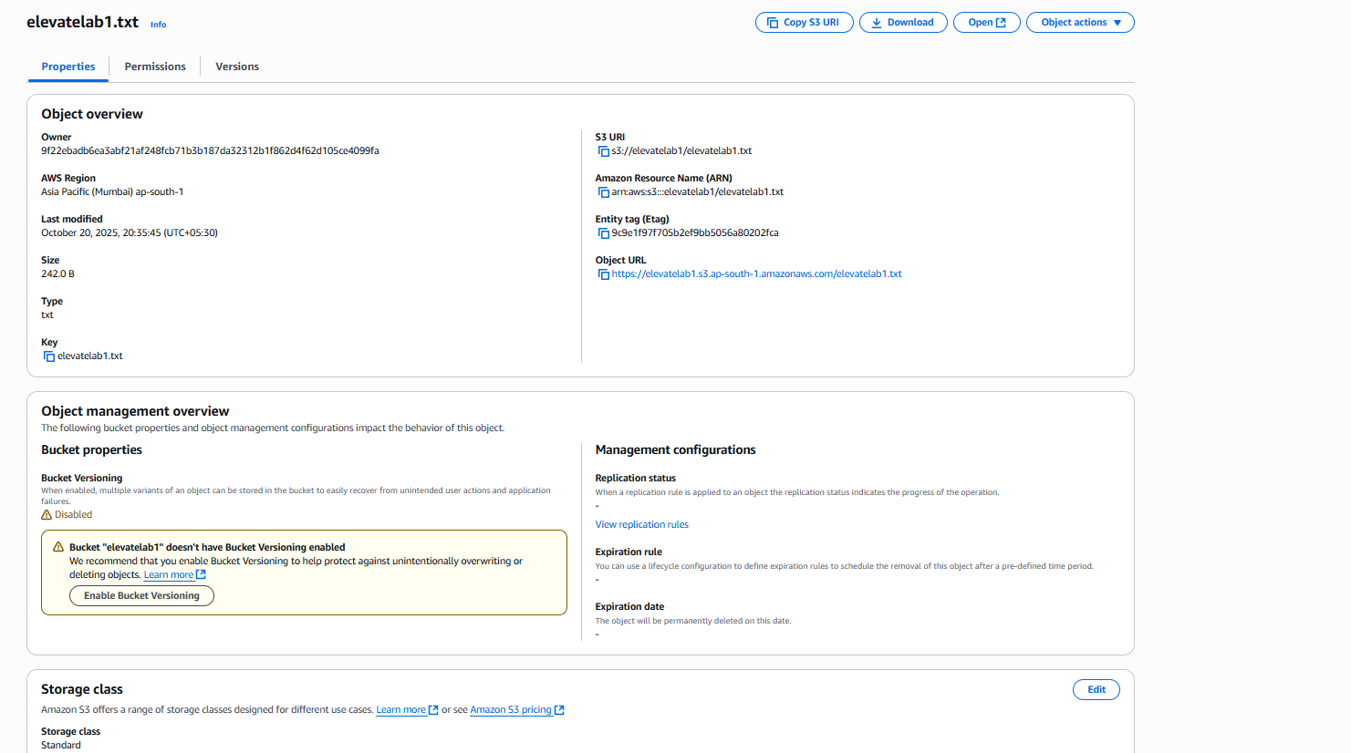

Creating bucket policy to upload a static website:

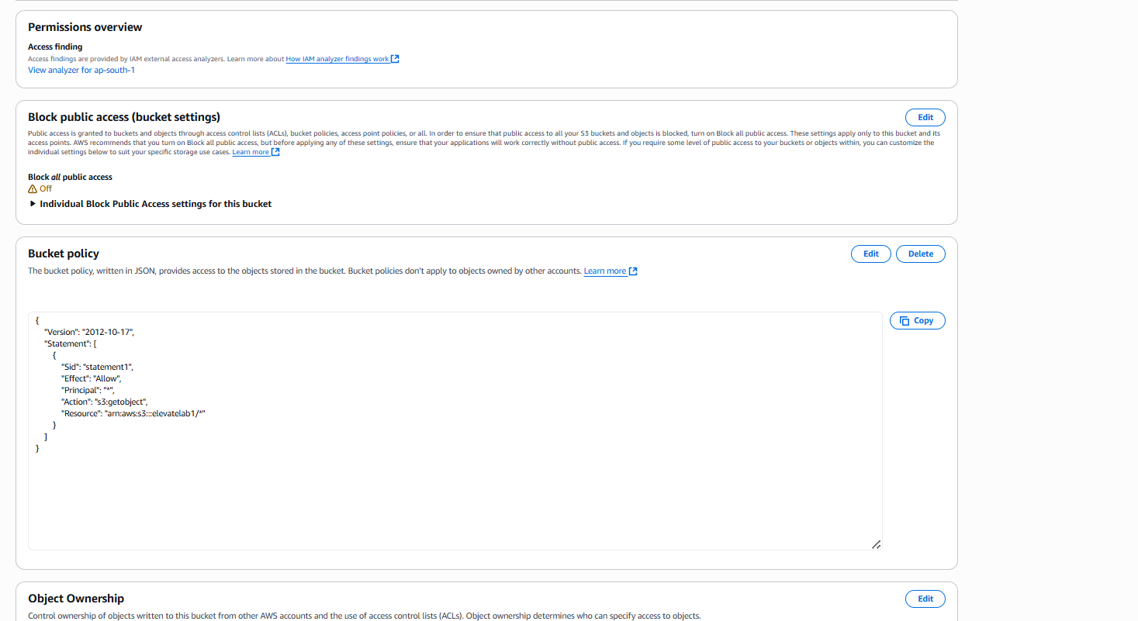

State website url:

Link: http://elevatelab1.s3-website.ap-south-1.amazonaws.com

